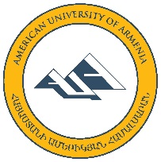

2014 AHEI SUMMER PROGRAM

Application Form

Please complete by 20 June, 2014 and send to info@armhei.org along with a resume
First name______________ Last name________________ Date of birth____________
University (past or current) ________________________________________________
Course of study__________________________________ Year in program__________
Telephone number____________________ E-mail_____________________________
If graduated, current occupation ____________________________________________

- In 150 words or less, please describe your professional, academic and research interests:

- In 150 words or less, please explain your expectations from the program:

- In 150 words or less, please describe what you think your contribution to the program will be:

- Please include any additional comments here:

Language Proficiency
 | Speaking | Reading (ability to read articles in your field) | Writing | 5 – excellent  4 – good  3 – average  2 – below average  1 – poor
Armenian
English
Russian
Other:
Please note that the language of instruction and communication during the Summer Program is Armenian.

Description of possible research topic

In the space below, please provide a brief description of a theme on which you would like to conduct research.

In signing this form and if selected, I agree to abide by the program’s rules, attend all the seminars and field trips and to contribute to a research project until its completion.

Signature: Date:

